**Practical No. 1**

1. **Using, linux-terminal or Windows-cmd, execute following networking commands and note the output:**

**ping, traceroute, netstat, arp, ipconfig, Getmac, hostname, NSLookUp, pathping, SystemInfo**

**Command: ipconfig**

**Output:**

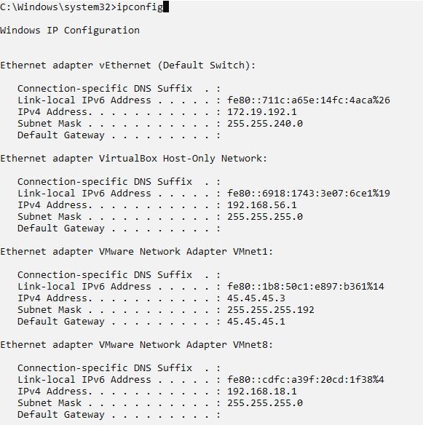

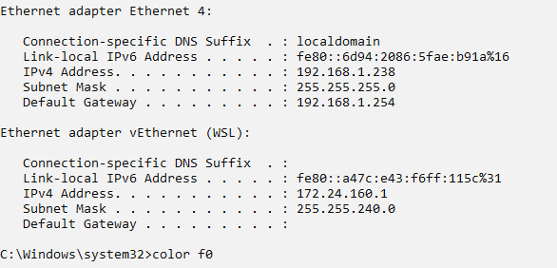

**Command: nslookup**

**Output:**

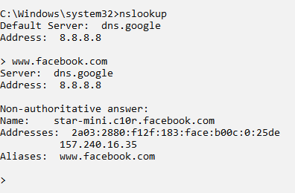

**Command: ping ip_address**

**Output:**

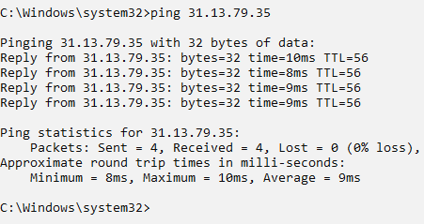

**Command: ping ip_address**

**Output:**

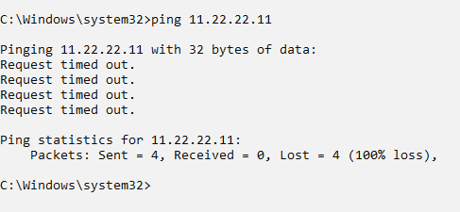

**Command: tracert**

**Output:**

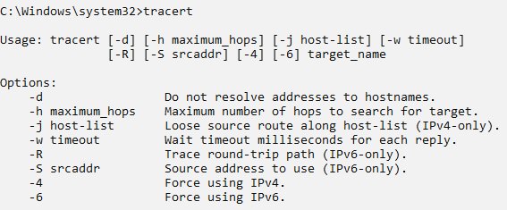

**Command: tracert web_address**

**Output:**

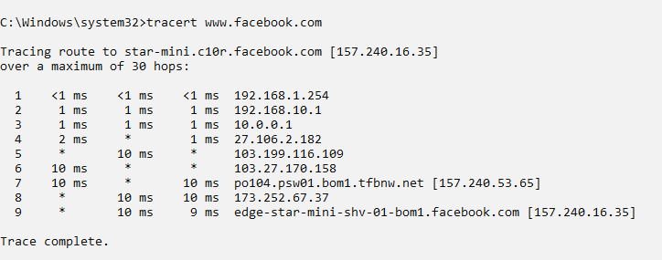

**Command: netstat protocol**

**Output:**

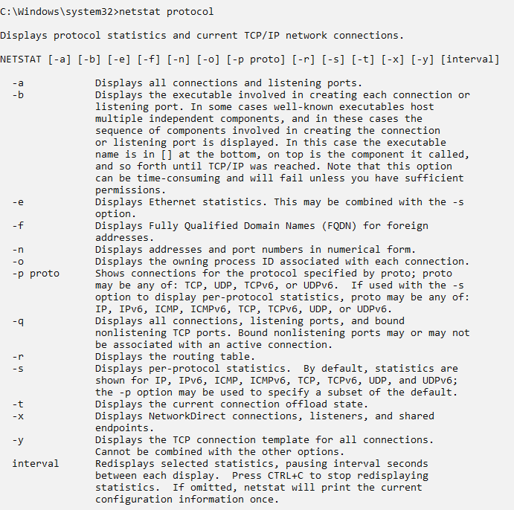

**Command: netstat -a**

**Output:**

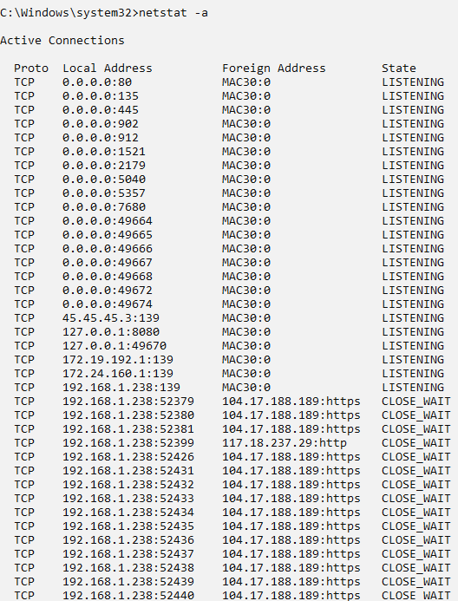

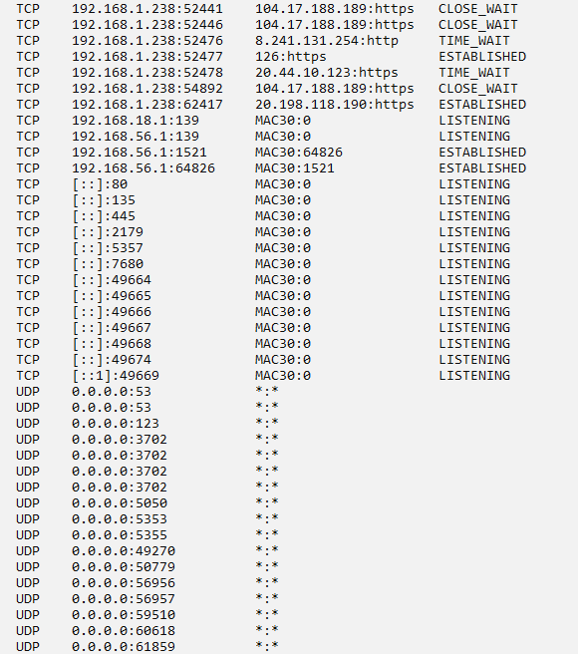

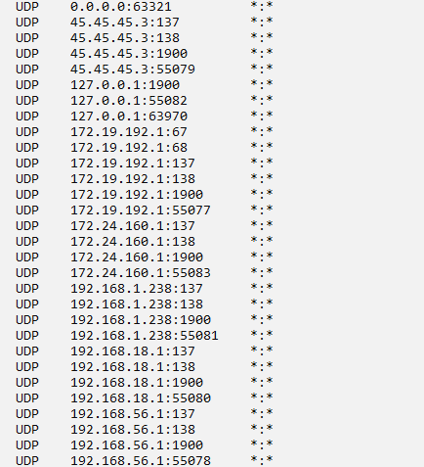

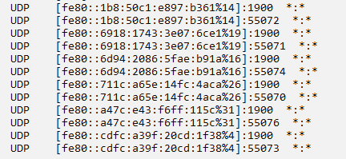

**Command: arp**

**Output:**

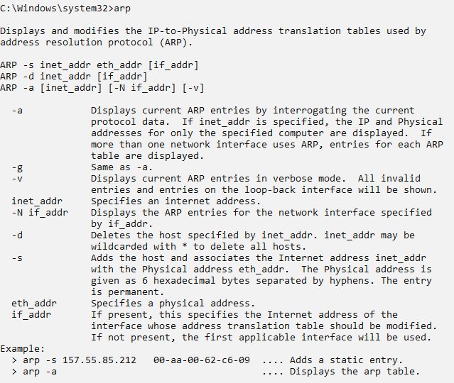

**Command: arp -a**

**Output:**

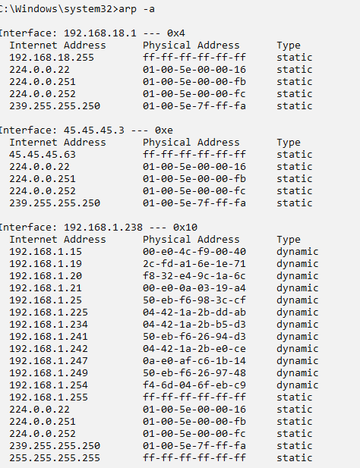

**Command: getmac**

**Output:**

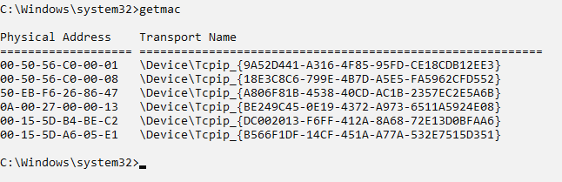

**Command : hostname**

**Output:**



**Command: pathping** [**www.facebook.com**](http://www.facebook.com)

**Output:**

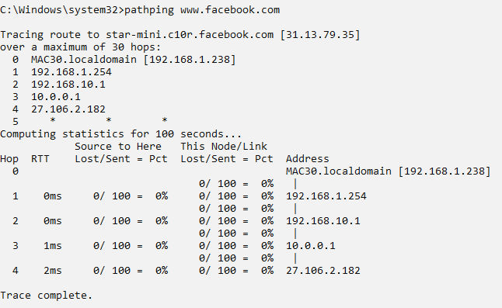

**Command: systeminfo**

**Output:**

